Experiment 1:
Code:
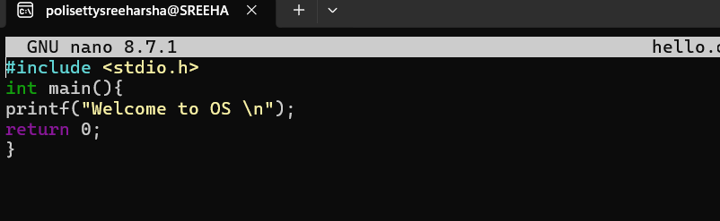
Output:
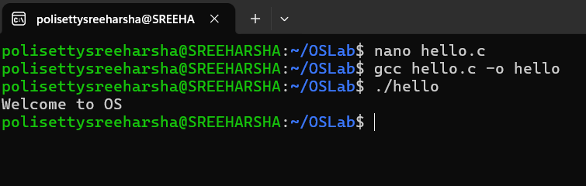

Experiment 2:
Code:
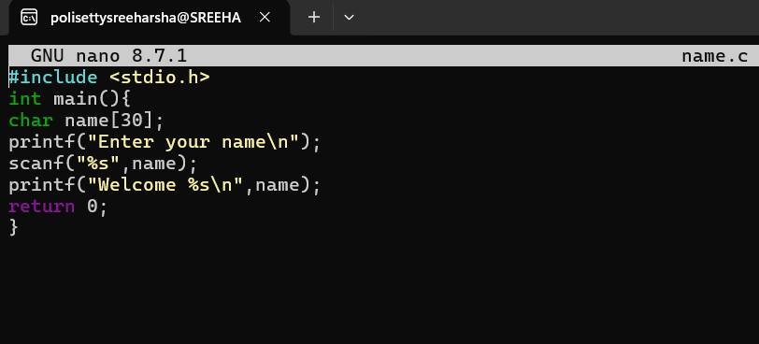

Output:
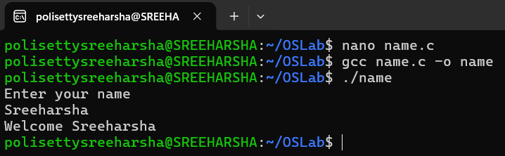

Experiment 3:
Code:
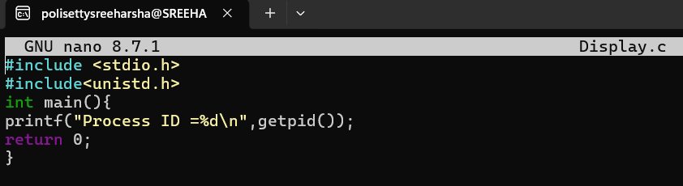
Output:
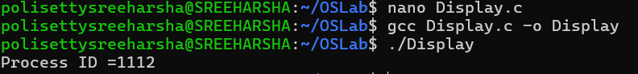

Experiment 4:
Code:
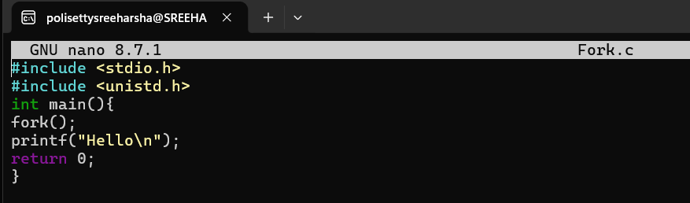
Output:
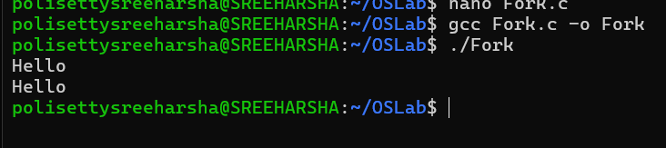

Experiment 5:
Code:
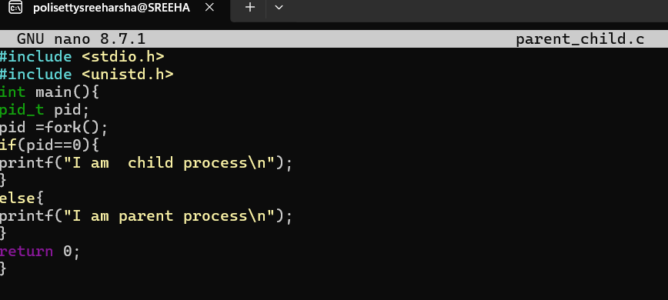
Output:
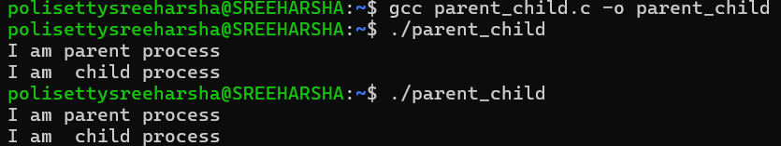

Experiment 6:
Code:
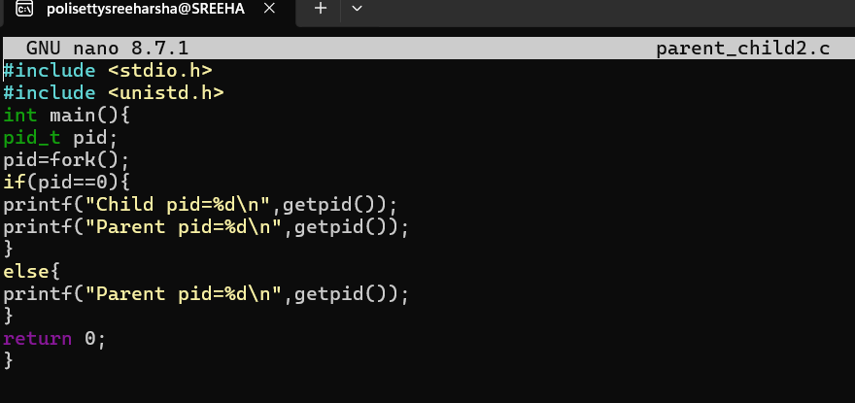
Output:
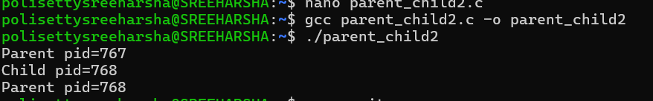

Experiment 7:
Code:
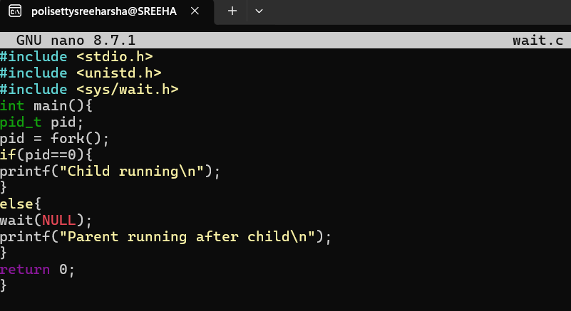
Output:
